Quiz: Evolution #2 Name______________________Date_________

___1) The theory that organisms have new traits that their ancestors did not have:
- Acquired traits
- Descent with modification
- Homologous structure
- All of these

___2) When 2 or more species evolve in response to each other:
- Coevolution
- Convergent evolution
- Divergent evolution
- Punctuated equilibrium

___3) The picture below demonstrates:
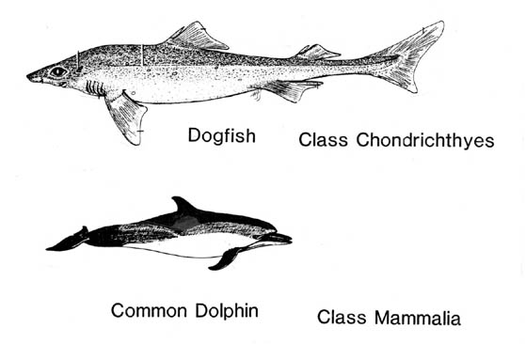
- Coevolution
- Convergent evolution
- Divergent evolution
- Punctuated equilibrium

___4) In a particular environment having very large feet is an advantage over having medium or very small feet. This demonstrates:
- Stabilizing selection
- Disruptive selection
- Extreme selection
- Directional selection

___5) The man who proposed natural selection as the mechanism for evolution:
- Darwin
- Mendel
- Watson
- Redi

